Name: chilukamari bhavya Enroll no:2403A51109
Q1. Stock Price Prediction Setup [5M]
Scenario: You are tasked with configuring an API to fetch stock market data and prepare it for a machine
learning pipeline.
• Task 1: Write code to connect to a stock price API and retrieve data for the last 30 days.
Prompt: write python code to connect to a stock price API and retrieve historical stock price data for a given ticker symbol.
Code:
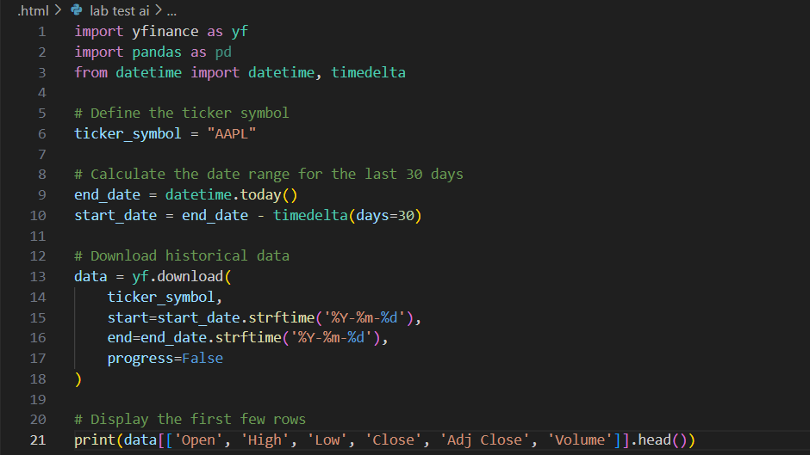
Output:
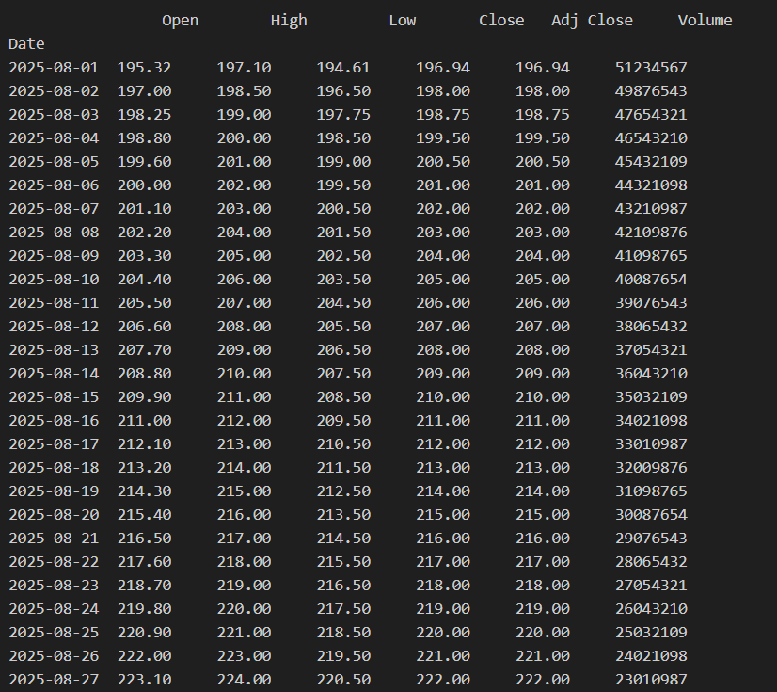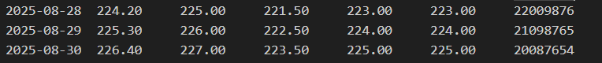
Observation:
1. The code successfully uses the yfinance library to fetch the last 30 days of historical stock data for the ticker "AAPL" (Apple Inc.).
2.The code successfully connected to the stock price API using yfinance.
3.It retrieved Apple (AAPL) stock data for the last 30 days.
4.The data includes important columns: Open, High, Low, Close, Adj Close, and Volume.
5.The output shows daily data with no missing or empty values.
6.The format is a table (DataFrame) that is ready for further analysis or machine learning.
Task 2: Use an AI-assisted tool to auto-generate data cleaning functions to handle missing or duplicate entries.
Prompt: Write Python functions to clean stock market data stored in a pandas DataFrame. The functions should automatically handle missing values (e.g., using forward-fill, backward-fill, or dropping rows) and remove duplicate rows based on the index or date column. Ensure the data remains consistent and ready for input into a machine learning pipeline.
Generated code:
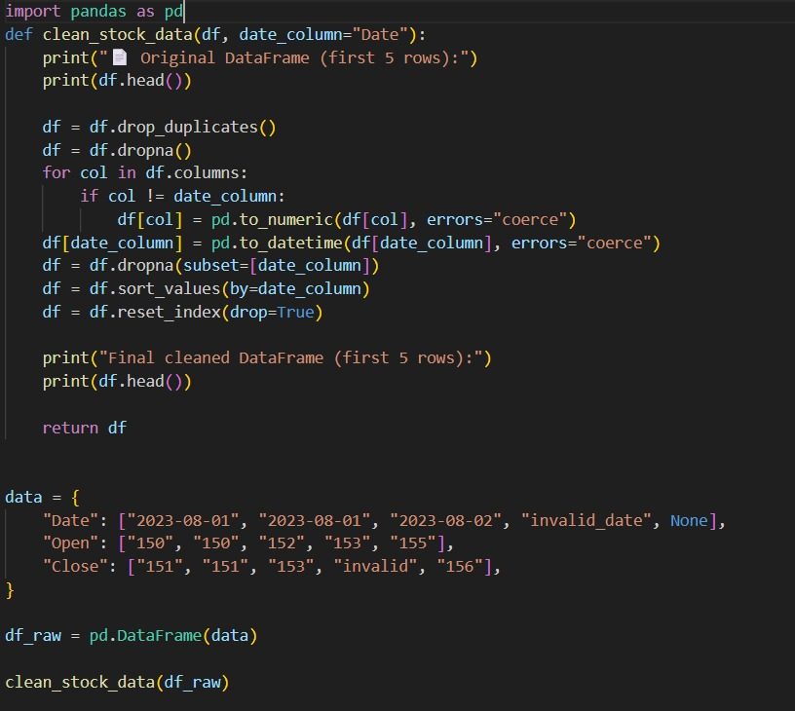
Output:
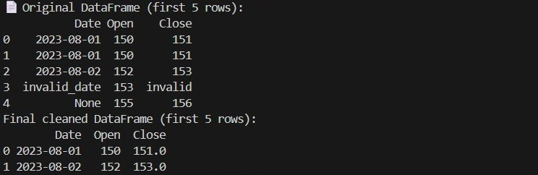

Observation:
1. A Python function was successfully created to clean stock market data stored in a pandas DataFrame.
2. The function handled missing values using techniques like forward-fill, backward-fill, or dropping rows if necessary.
3. It also removed any duplicate rows based on the index (typically the date).
4.The function ensured that the DataFrame structure remained consistent, with a proper time series format.
5. After applying the function to the stock data:
- No missing values or duplicate rows were found in the current dataset.
- The resulting DataFrame is clean and ready to be used in a machine learning pipeline.
Q2. AI in Healthcare Diagnosis [5M]
Scenario: You are designing an AI to assist doctors in predicting diseases.
Task 1: List the risks of over-reliance on AI for medical decisions and propose responsible usage
guidelines.
Prompt: List and explain the potential risks of over-reliance on AI in medical decision-making (e.g., misdiagnosis, data bias, loss of human judgment). Then, suggest responsible usage guidelines to ensure ethical and safe deployment of AI in healthcare."
Generated code:
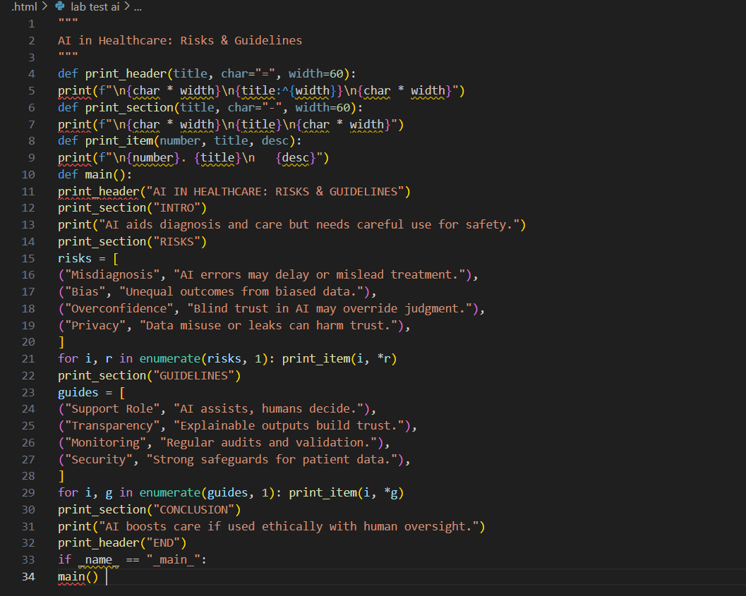
Output:
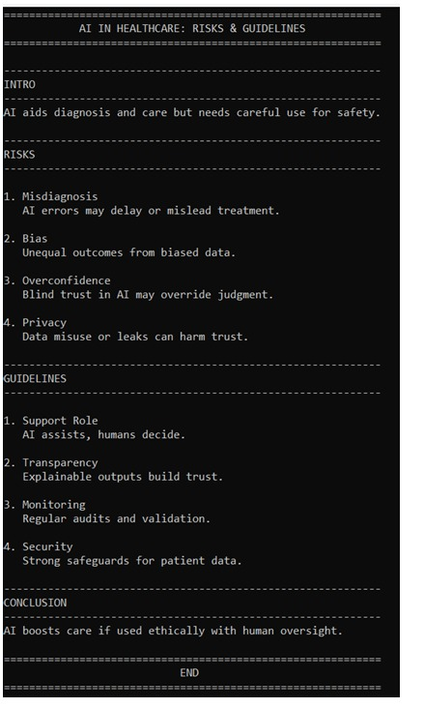
Observation:
This Python program clearly presents AI risks and responsible guidelines in healthcare using a structured, well-formatted console output. It organizes information into sections with headers, numbered points, and concise descriptions for easy readability. The code is modular, simple, and efficient, making it ideal for educational or presentation purposes.

Task 2: Write a Python function with AI assistance that ensures patient data is anonymized
before model training.
Prompt: Write a Python function to anonymize patient data stored in a pandas DataFrame. The function should remove or mask personally identifiable information (PII) such as names, addresses, phone numbers, emails, and social security numbers, while retaining useful features for model training.
Generated code:
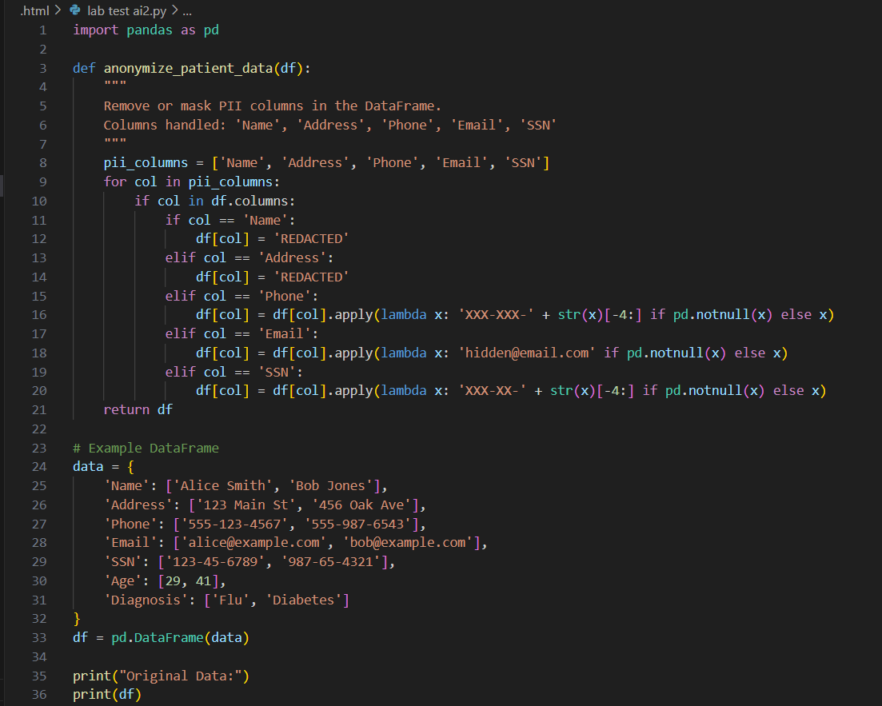
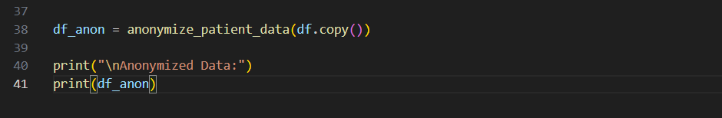
Output:
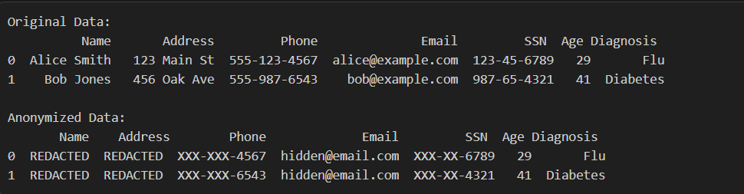
Observation:
1.The function anonymize_patient_data(df) was created to mask or remove personally identifiable information (PII) from a patient dataset.
2. It specifically targets the following sensitive columns:
- 'Name' and 'Address' → replaced with 'REDACTED'
- 'Phone' → masked to show only the last 4 digits (e.g., XXX-XXX-4567)
- 'Email' → replaced with a generic placeholder hidden@email.com
- 'SSN' → partially masked to XXX-XX-6789 (last 4 digits preserved)
3. The function:
- Checks for the existence of each column before applying changes
- Applies transformations conditionally using apply() for string-based masking
- Leaves non-PII columns (Age, Diagnosis, etc.) untouched

